
NSS UNIT VIT BHOPAL UNIVERSITY
Kotri Kalan, Astha, Indore – Bhopal Highway
Bhopal Madhya Pradesh -466114

EVENT DESCRIPTION
Date | 16th April 2024
Event Title | National Youth Parliament 2024
Event Date | 16th April 2024
Venue/Mode | Auditorium/offline
Organizer | NSS Unit VIT Bhopal
No of participants | 50
Program officer(s) | Dr. Vinod Bhatt and Dr. Abha Gupta
Brief about the event (context and Learning outcomes)
The NSS unit of VIT Bhopal orchestrated the National Youth Parliament at VIT Bhopal University on April 16, 2024. The event commenced with a symbolic lamp lighting ceremony paying homage to Swami Vivekananda and Maa Sharda. Mr. Sankar Viswanath, Vice President of VIT, and Dr. Debasis Adhikari, Registrar, alongside NSS Program Officer Dr. Vinod Bhatt and Dr. Abha Gupta, initiated the proceedings, marking the onset of a day dedicated to profound debates and discussions on national issues.

Speaker Mr. Ishaan Batra inaugurated the parliamentary discussions with representatives from both ruling and opposition parties, emphasizing the treasury's pivotal role. Throughout the session, leaders from both sides deliberated on crucial subjects such as the media's role in democracy, "one nation, one election," and the practical realization of Make in India. Two bills were subsequently passed after thorough deliberation and debate, culminating in a closing address by the Prime Minister, signifying the conclusion of the session.

The National Youth Parliament event aims to ignite political awareness among students by providing them with a simulated parliamentary platform for debates. This platform is crucial for several reasons: Firstly, it immerses young individuals in a parliamentary environment, facilitating a better understanding of its operations. Secondly, it provides a forum for discussing national issues on a large scale under the guidance of experienced moderators. Lastly, it fosters a sense of community among like-minded youth, encouraging constructive dialogue and the exploration of solutions. The objectives of the youth parliament encompass cultivating students' understanding of parliamentary procedures, fostering opinion formation on public matters, refining group discussion skills, nurturing collective decision-making abilities, and fostering respect and tolerance for diverse viewpoints.
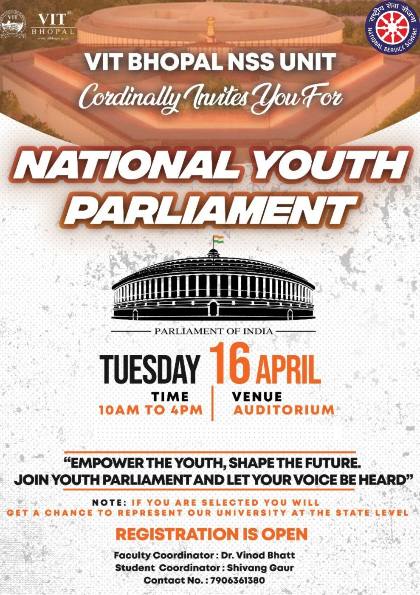

Session Schedule

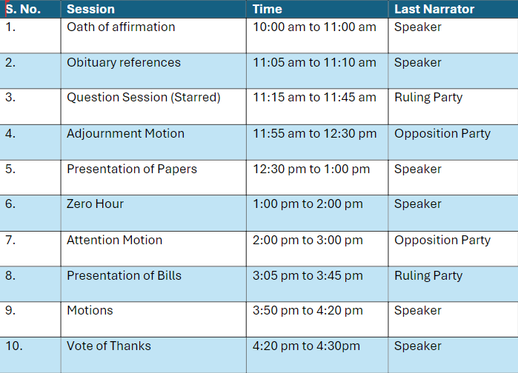

For more info, contact
- Shivang Gaur – 7906361380
Shivanggaur2022@vitbhopal.ac.in

- Ayush Saxena – 7818006139
ayushsaxena2022@vitbhopal.ac.in

